**Charges:**

* Items are made out of positive and negative charges
* Like charges repel. Opposite charges attract
* A neutral object has the same number of positive charges as negative charges
* Neutral objects do not attract or repel other neutral objects
* Positive charges are attracted to negative charges
* A charged object is attracted to a neutral object

e.g. of the large negative charge on the balloon causes a local rearrangement of charges on a neutral balloon. The neutral object is attracted to the negatively charged balloon.

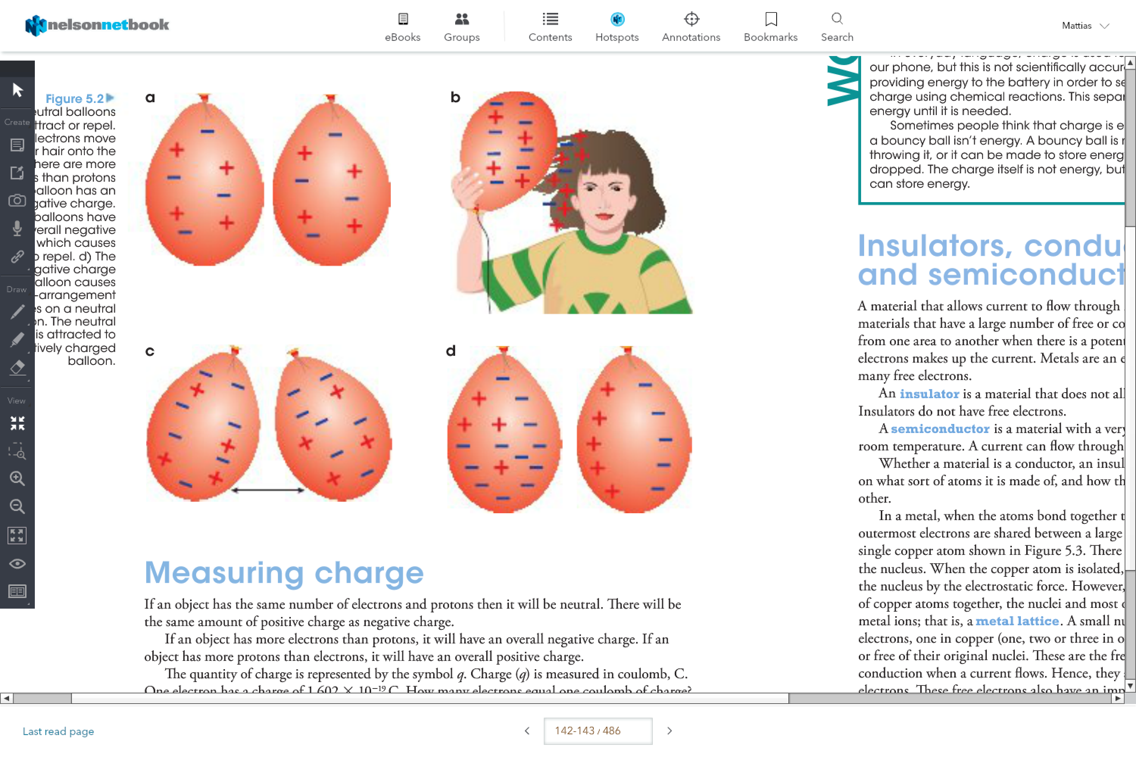

The amount of charge depends on the difference between the number of protons and the number of electrons

Charge cannot be created nor destroyed, but it can move from one object to another.

Charge:

How to calculate q:

e.g. no of electrons in 1C (coulomb)

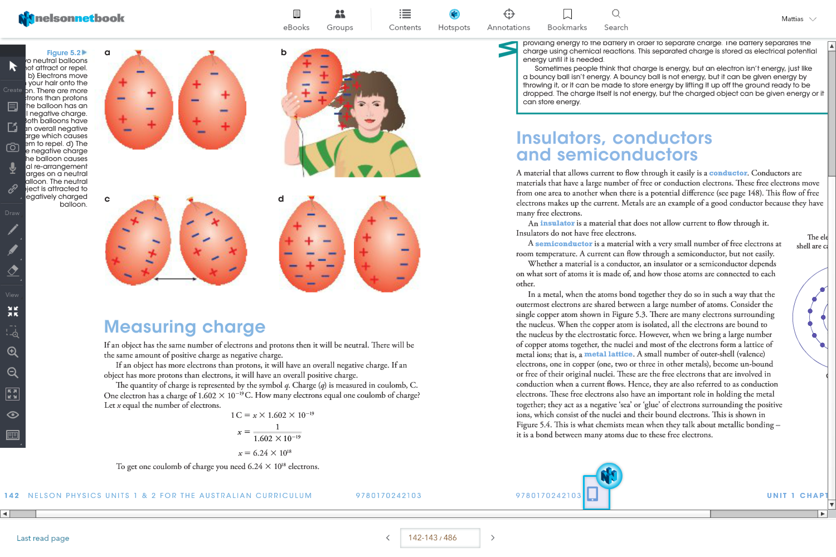

Insulator:

Does not let a current go through it, does not have free electrons

* Do not have free electrons

Semi-conductor:

It only has a few moving electrons at room temperature, this means that some current passes but not easily

* Has a small number of free moving electrons
* A current can flow through but it’s quite hard

Conductor:

A material that allows current to flow through it easily, normally has a lot of free moving electrons

* Have a large number of free (conduction) electrons
* The current is the net movement of these electrons

Electrical Circuit:

Is a complete loop through which charges flow. If the loop is not complete, then charge cannot flow.

**Circuit Symbols:**

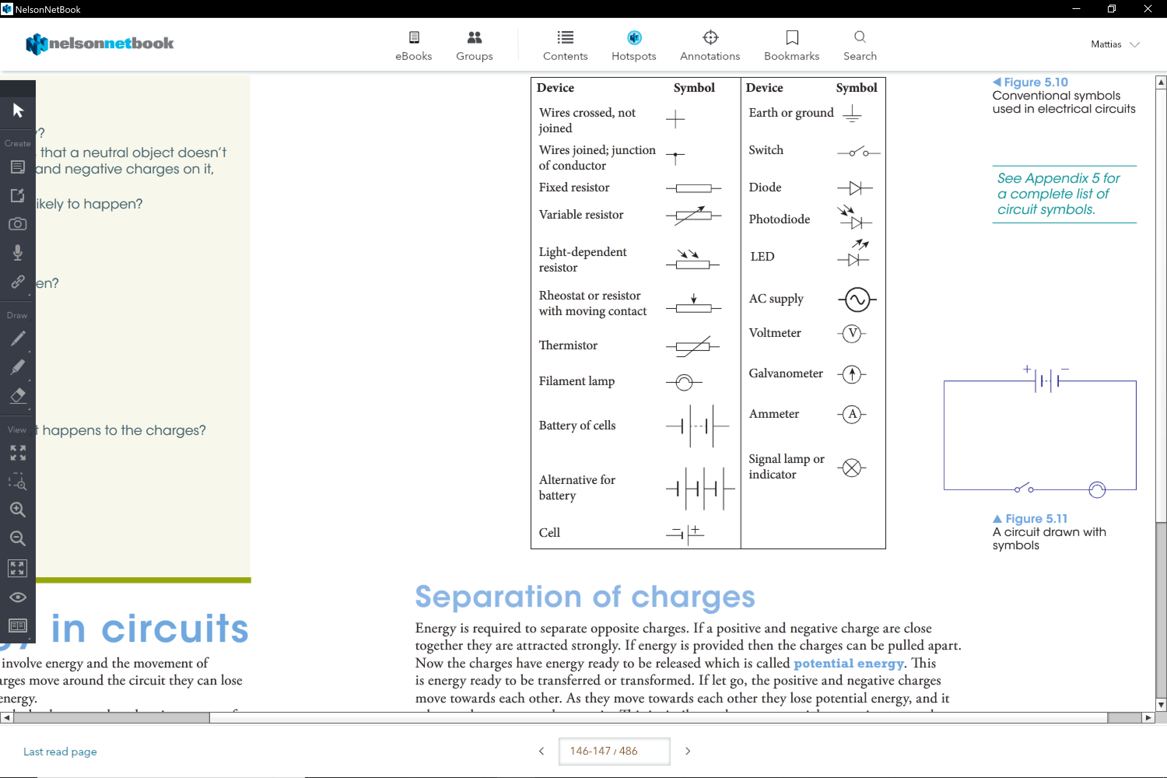

Separation of charges:

* Work is done on unlike charges to separate them. Potential energy increases the further apart they are. Unlike charges lose potential energy as they approach each other.
* Work is done on like charges to bring them together. Potential energy increases the closer they are. Like charges lose potential energy as they separate.

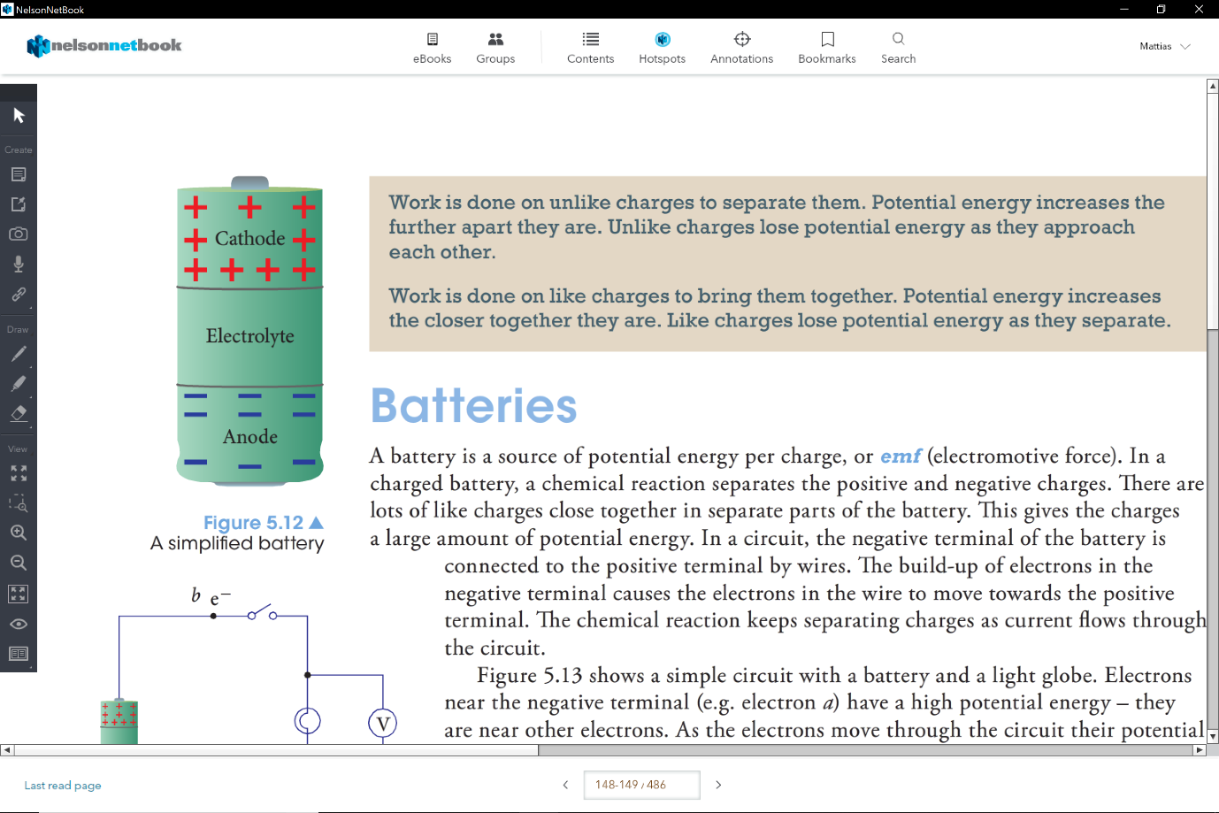Batteries:

* A chemical reaction separates the positive and negative charges
* The build up of electrons in the negative terminal causes the electons in the wire to move towards the positive terminal.
* the chemical reaction keeps the separating charges as current flows through the circuit.

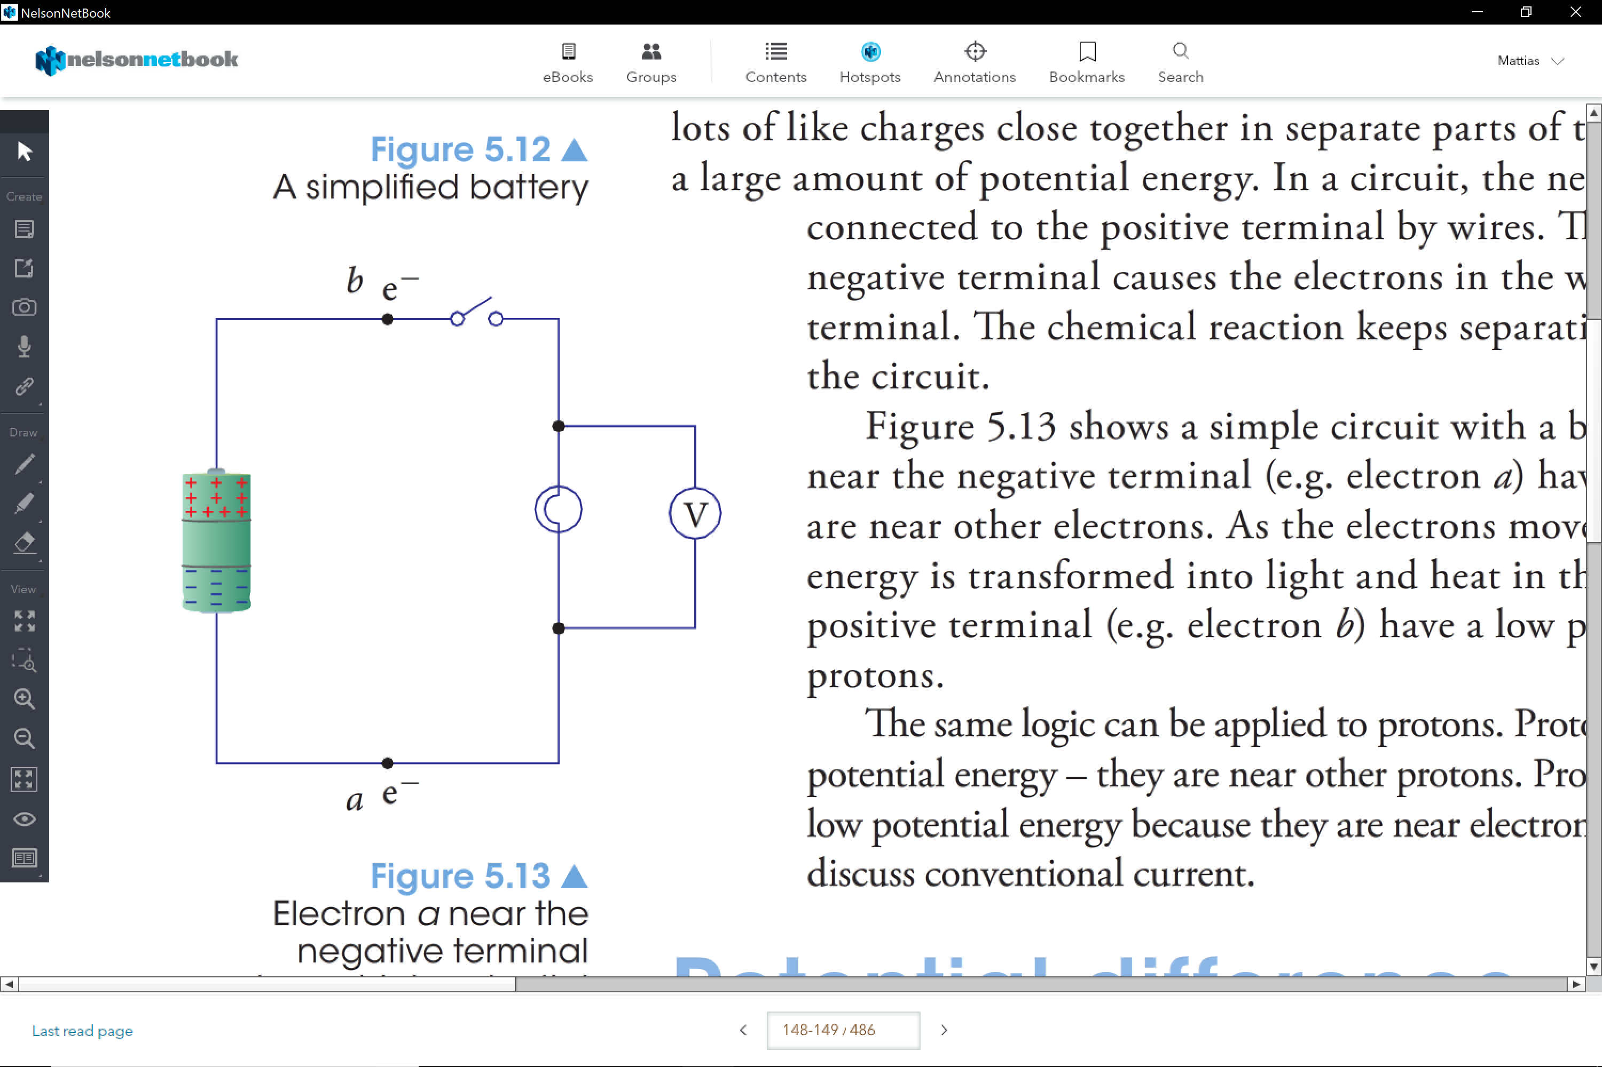

The electrons near the negative terminal have a higher potential energy- they are nearer to other electrons.

The potential energy is transformed into light and heat in the globe.

Electrons near the positive terminal have a low potential energy because they are near many protons

**Potential Difference:**

Electric Potential Is how much potential energy there is for each charge at different locations in a circuit.

It is measured in V which is J/C.

* We measure the potential at a point relative to come reference point

The **potential difference** is the difference in potential energy per unit charge between those two points.

**Voltmeter:**

* It measures the potential difference
* Measures the potential between two points
* It is normally connected in parallel to two different parts of a circuit

**Current:**

Is the rate of flow of a charge.

The current depends on the amount of charge that passes a point and how long it takes those charges to pass that point

1A = 1C per second

Conventional Current:

It describes the direction of the current as the flow of positive charges flowing from the positive terminal to the negative terminal

**Direct and Alternating Current:**

This is how electricity is supplied.

DC:

* The net charge flows in one direction.
* Used for things like mobile phones, torches and toys

AC:

* The charge flow alternates
* Normally the alternating current has serious affects on the nerve response.
* Uses in car alternators and motors.
* Power points are normally Ac, due to it being **simpler to produce,** **transmit** and there is **less power loss.**

A wall socket in Australia is normally 240V and a frequency of 50 Hz.

**Series Circuit:**

* The charged particles only have one path to go along
* This causes at each point the flow of charge (current) to be the same.

**Parallel Circuit:**

* There are at least5 two pathways for the charged particles to travel.
* At a junction they can go either way but the total number of charged particles that arrives at the junction each second must be the same as the total number that leaves junction each second.

**Kirchhoff’s Current Law**

The sum of the currents entering a junction equals the sum of the currents leaving the junction

**Kirchhoff’s Energy Law**

The sum of the potential difference from sources is equal to the sum of the potential difference used in the circuit.

**Resistivity:**

Refers to how much a material opposes the flow of charge

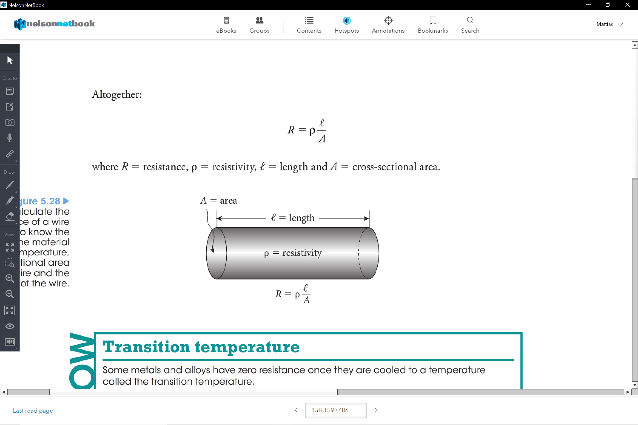

**Resistance:**

Opposition to flow of electrons

**Ohm’s Law**

It states that current through a conductor between two points is directly proportional to the potential difference across two points

I= V/R

**Ohmic Devices:**

Is a component with **constant resistance** for different values of V and I

* When using a graph you can use the gradient, which is the resistance.

V=IR

Non Ohmic Devices

Is a component, which its resistance is not constant

* However you can calculate the resistance at one certain point by using the formula V=IR

**Power:**

Is the rate of energy transfer per unit of time (seconds).

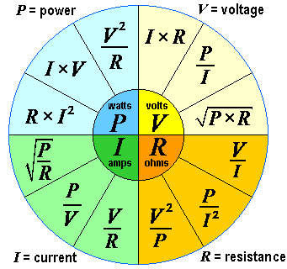

Converting to Kilowatt-hours:

! kilowatt-hour = 1 kWh = 3.6 x 106J

Therefore, J=> kWh = xJ/ (3.6 x 106J)

kWh=> J = x kWh x 3.6 x 106J

**Thevenin’s Theory:**

A circuit can be reduced to one source that is equivalent of ll the sources, and one load that is equivalent to all the loads

** like Mr Wood always says, a battery may only see a simple circuit of a resistor, its self and a switch.

**Resistors in Series:**

The total resistance is equal to the sum of all the components’ resistance.

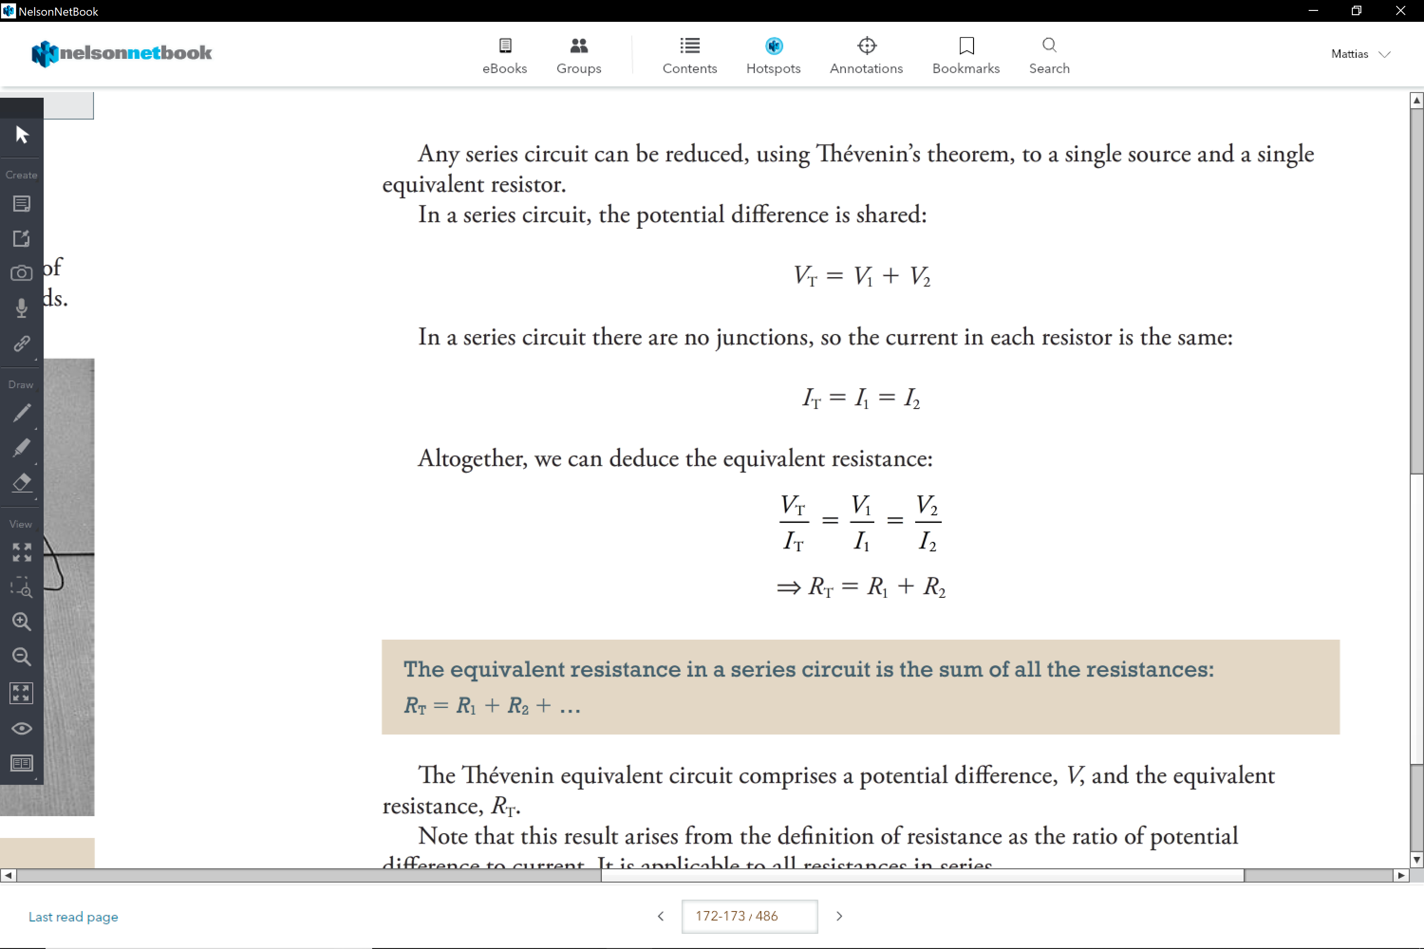

**Resistors in Parallel Circuits:**

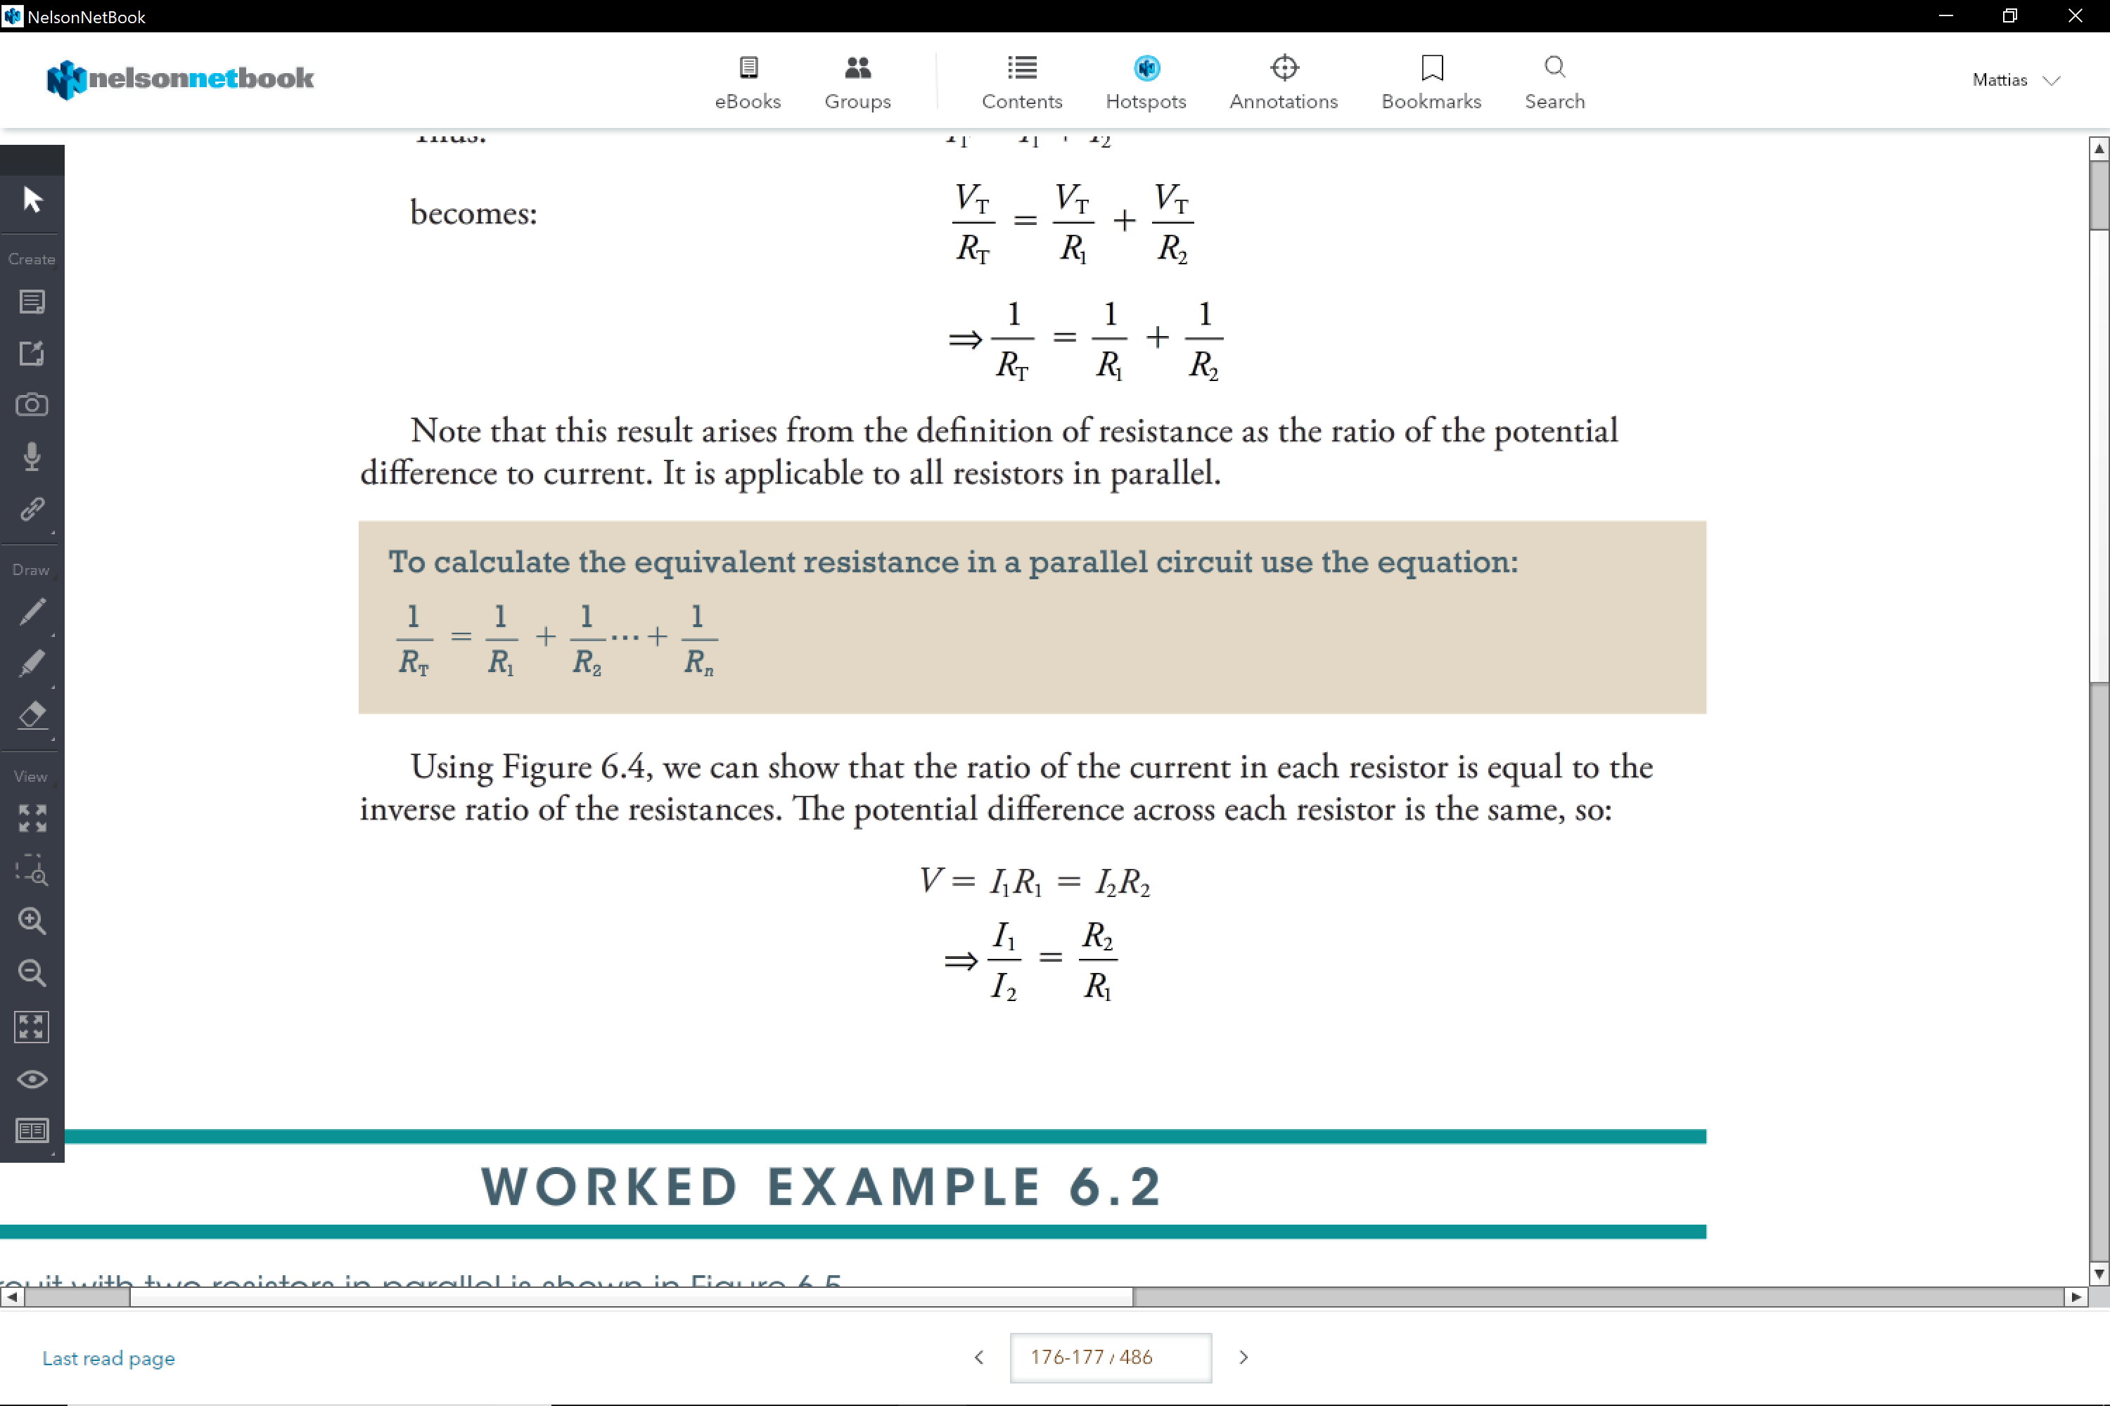

Combination Circuits:

Elements connected in series and in parallel groups.

To help calculate problems with combination circuits

Use Vt= It x Rt

**Household Electricity:**

* The power points in houses are 240V 50Hz

Active Wires (brown):

Is the section of cabling that goes to the load

Neutral Wire (blue):

It is the section of wire that comes out of the load

-These wires connect to the circuit, which means that power is supplies to the appliance.

Earth Wire (Green and Yellow)

* It is connected to the metal case of the appliance, if there is a fault it causes the circuit breaker to activate due to the difference in current.

Short Circuit:

Is a connection between two points that allows current to flow with negligible resistance

* It causes the current to become much greater than its normal use, due to the bypass of the resistance.

**Safety Devices:**

Fuse:

Is a short piece of wire selected so that it will melt when the current exceeds a certain value

* They are normally 15A or 30A
* They do take a will to break so in many cases they take a while to break

Circuit Breaker:

It is an electromagnetic device that automatically opens a switch is an overload occurs.

* Uses an electromagnet to activate this switch.

**The main switch/ meter box is always on the active wire. When the power is supplied; It allows the house to be isolated from the live wires.

Residual Current Device (RCD):

It is a earth leakage protection device; safety protection against overload

* It measures the difference in current which should be the same
* When there is a difference it means that the current must be going somewhere else (grounded)
* This causes the switch to open

Double Insulation:

It is functional and protective layers of insulation that enhance safety devices.

* The first layer is protecting the live wires
* The second layer is a plastic layer that is for protection.